EXPERIMENT 13
Aim:
To design an infographic in Figma comparing mobile communication and mobile computing.
Procedure:
- Open Figma and create a new design file.
- Create a frame for the infographic.
- Divide the frame into two sections.
- Add mobile communication details to the first section.
- Add mobile computing details to the second section.
- Include their purposes, technologies, features, and examples.
- Add suitable icons, colors, and headings
- Arrange the information neatly for easy comparison.
OUTPUT:
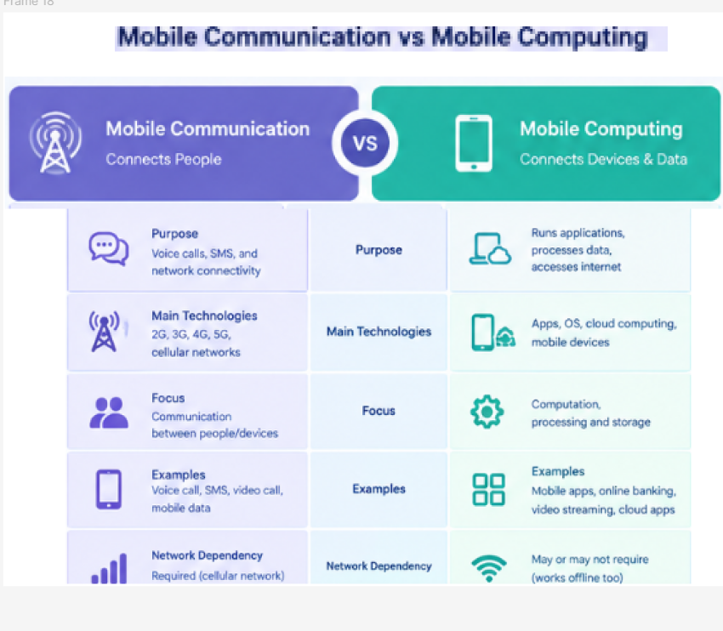

FIGMALINK: https://www.figma.com/design/ED1qcVpNfWi2Zuft4amJyZ/Untitled?node-id=68-151&t=zih8IyL283jodQsH-0

RESULT:An infographic comparing mobile communication and mobile computing was successfully designed in Figma.

